### Downloading LinkedIn Learning Videos

<https://www.youtube.com/watch?v=rbpuQ7wuXXM>

**1.Download from GitHub**

* Original , but not available: **mclmza/linkedin-learning-downloader**
* Available : <https://github.com/pulkitmaloo/linkedin-learning-downloader>

2.**Open PowerShell in Admin mode**, go to extracted location & Run below Command

pip install -r requirements.txt

3.In the **config.py file**, write your login info and fill the **COURSES** **array** ,the courses you want to download, for example:

You can find the Course name @

https://www.linkedin.com/learning/**it-security-foundations-core-concepts**/



**4.Then execute the script:**

python lld.py

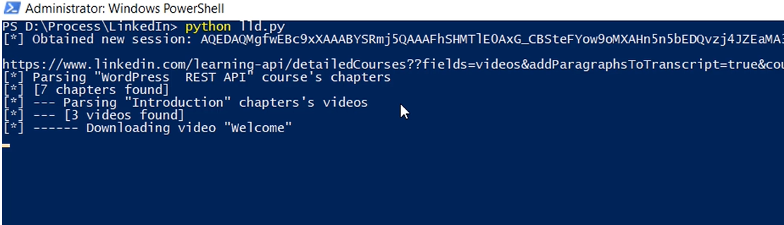

5.The courses will be saved in the out folder.

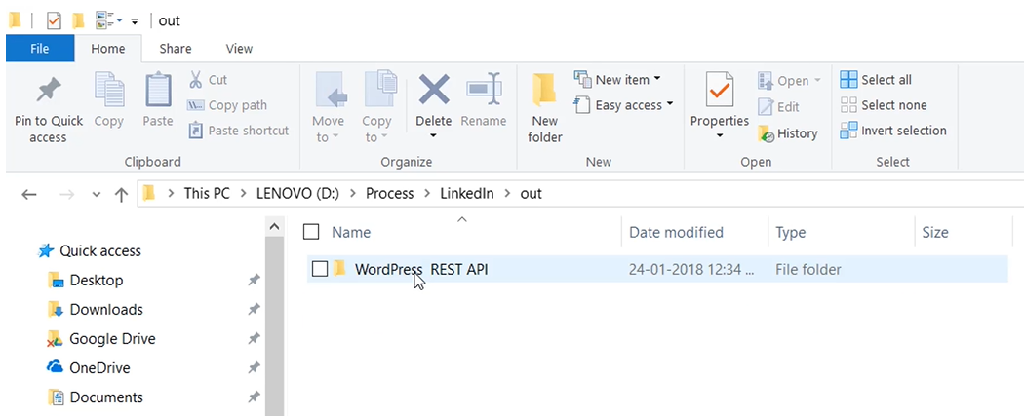

### youtube-dl linkedin learning

<https://github.com/ytdl-org/youtube-dl>

## set xampp mysql root password

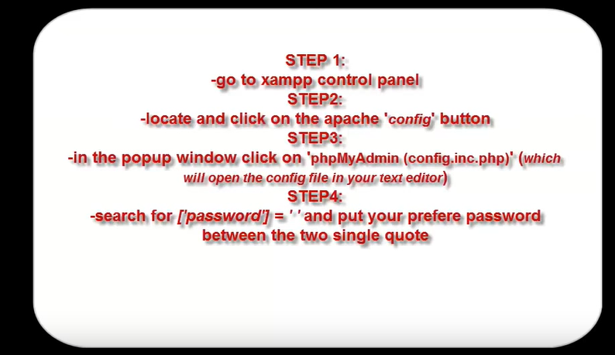

**Method 2: reset XAMPP MySQL root password through SQL update:**

1. Start the Apache Server and MySQL instances from the XAMPP control panel.
2. After the server started, open any web browser and give **http://localhost:8090/phpmyadmin/** (if you are running XAMPP on 8090 port). This will open the phpMyAdmin interface. Using this interface we can manager the MySQL server from the web browser.
3. In the phpMyAdmin window, select *SQL* tab from the right panel. This will open the SQL tab where we can run the SQL queries.
4. Now type the following query in the textarea and click **Go**  
   UPDATE mysql.user SET Password=PASSWORD('password') WHERE User='root'; FLUSH PRIVILEGES;
5. Now you will see a message saying that the query has been executed successfully.
6. If you refresh the page, you will be getting a error message. This is because the phpMyAdmin configuration file is not aware of our newly set root passoword. To do this we have to modify the phpMyAdmin config file.
7. Open the file **[XAMPP Installation Path] / phpmyadmin / config.inc.php** in your favorite text editor.
8. Search for the string $cfg\['Servers'\]\[$i\]['password'] = ''; and change it to like this, $cfg\['Servers'\]\[$i\]['password'] = 'password'; Here the ‘password’ is what we set to the root user using the SQL query.
9. Now all set to go. Save the config.inc.php file and restart the XAMPP server.